Summary
The testing that I conducted for each of the three features followed the same framework. I tested all the objects and methods that the features utilized to validate that no illegal inputs could occur (i.e. null values and values out of the scope provided by the user). The following code below conducts tests for valid inputs in testContact() and invalid inputs in testInvalidContactId():
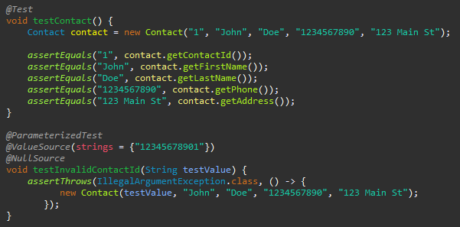
Invalid and valid inputs are tested for all objects to make sure that the requirements are met. The code above showcases the format that was utilized for my testing. I would have a test for the Constructor that would only input valid values while I would have separate tests for invalid values.
I utilized parameterized tests which allow me to test a variety of inputs without repeating the same code. As seen above, the invalid contact id test utilized a value source and a null source. Both are invalid, but the test is conducted through the same method which helps reduce clutter and enhances readability. Since I could test multiple values in the same method, it allowed me to provide maximum coverage to my code to prevent any errors in logic. As seen in the code above, when a Contact object is created it runs the constructor shown below:
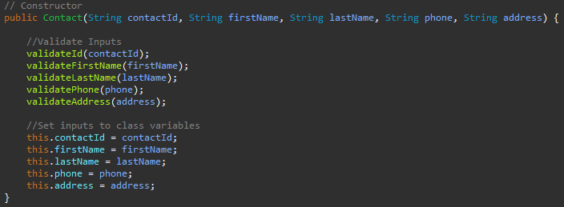This constructor runs the validation method for each object in a Contact class.
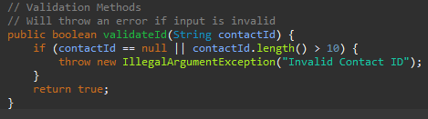
My JUnit tests conduct tests that attempt to utilize values that would throw an exception as well as pass the if statement and return true. These tests ensure that the methods are functioning as expected. My code was technically sound because each scenario was tested at least once. As shown in the validateId() method, a test would be conducted for a null value, a value out of bounds, and a passing value that allows the method to return true. The rest of my tests follow a similar format and allow for efficient testing. The following tests shown below showcase the same format utilized in my tests:
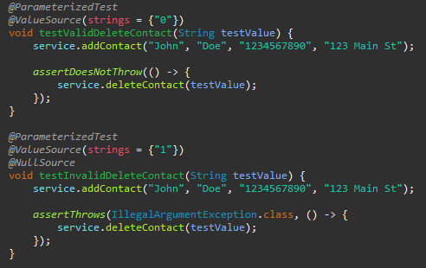
A valid test is conducted, and the invalid test is conducted with two different values for testValue: null and “1” which is out of bounds.
Reflection
Throughout each of the milestones I utilized manual, automated, functional, unit, and integration testing. While not present in the code anymore as I deleted the line of code when it wasn’t needed anymore, I utilized print statements as a form of manual testing when I was debugging my code. This helped me narrow down where errors in my code were coming from as it could help me keep track of what data was stored in specific variables at certain points in the runtime. I utilized automated testing using JUnit tests. The use of JUnit tests coincides with the functional, unit, and integration tests because the JUnit tests that I created tested the functionality of the program, individual methods within the classes, and the integration of the different methods within the classes.
Some of the software testing techniques I didn’t use include non-functional testing, system testing, acceptance testing, etc. Non-functional testing tests the usability and reliability of the product. Non-functional testing would help benefit the product's performance and user experience. System testing focuses on testing the complete software. This type of testing verifies that the system works as expected and that it meets the requirements that the product was created to achieve. Acceptance testing follows system testing as it ensures that the product satisfies the user’s needs. An example of acceptance testing is the User Acceptance Testing (UAT) where requirements that will be often utilized by end users will be picked for testing.
For different software development projects and situations, manual testing is very useful during the early stages of development. The print statements I utilized helped me to follow the flow of the runtime, which can make it easier to isolate logic errors in my code. This type of testing works well in smaller projects but does not scale well in larger projects as it is prone to human error.
Automated testing, however, does work well in larger projects. Automated tests help ensure that the functionality is consistent and reliable as the code changes within a project. They serve to quickly verify that the existing functionality still works.
Unit testing validates individual methods/components in isolation, which can help developers identify defects before they affect other components of a system. This is essential when dealing with systems that contain many components.
Functional testing ensures that the software adheres to the requirements that the software was created to achieve.
Integration testing verifies that the different components can work together without issue. This type of testing can help to discover aspects such as mismatched interfaces or incorrect data flow.
Non-functional testing focuses on the performance and usability of the software. Performance can heavily affect usability, so it is important to conduct this type of test. An example of a bug found through non-functional testing would be a memory leak which would eventually result in poor performance or an eventual crash.
System testing encompasses the complete software and ensures that all components work correctly together. This coincides with acceptance testing where the customer/business confirms whether the software meets their needs or not. The acceptance testing steps ensure that the requirements that development team had and the requirements set by the customer/business are aligned.
While working on this project, I was cautious not to incorporate redundant or garbage lines of code. An example of reducing redundant code would be the incorporation of the validation methods. The validation methods can be utilized any time an object’s input needed to be validated instead of repeating the same code in multiple different methods. Garbage lines of code would be adding a setter method for the Contact ID object despite the requirements specifying that it can’t be changed. The interrelationships that exist within my code also made it easier to conduct tests since testing certain methods would indirectly test other methods such as my Constructor test for the Contact class testing the validation methods.
To limit the bias when reviewing my code. I made sure that I referenced the requirements provided to me when developing my code. When developing the test cases, I avoided modifying them unless the test itself had a clear error. This made sure I was adjusting my code to pass the test rather than revising my test to fit my code.
It is important that I discipline myself to develop quality code because cutting corners on writing and testing code can lead to serious problems. The testing stages are intended to catch errors before a product reaches the deployment phase. Without quality testing, a product can face significant setbacks, which is a problem when deadlines must be met. To avoid accumulating technical debt, I need to hold myself to a higher standard. If I let those standards slip, not only will it cause problems for myself, but also any teams that I will work with. Tests play a vital role in the Software Development Life Cycle (SDLC) and cutting corners can allow minor bugs to become major issues.

